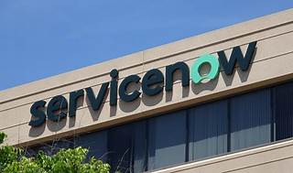

Explore

**ServiceNow** is a **cloud-based platform** that allows organizations to work across various functions and systems, offering solutions for IT, customer service, operations, HR, and more. [It leverages AI, machine learning, and low-code tools to optimize and automate work1](https://www.edureka.co/blog/what-is-servicenow/).

Here are **five free resources** where you can learn more about ServiceNow:

1. [**ServiceNow Learning**](https://nowlearning.servicenow.com/): Explore self-paced courses, real-time training sessions, and career journeys to enhance your ServiceNow skills[2](https://nowlearning.servicenow.com/).
2. [**ServiceNow Blog**](https://www.servicenow.com/blogs/2020/online-learning-and-certification.html): Access on-demand courses, videos, webinars, and interactive tools to accelerate your learning journey[3](https://www.servicenow.com/blogs/2020/online-learning-and-certification.html).
3. [**ServiceNow Learning Library**](https://www.servicenow.com/content/dam/servicenow-assets/public/en-us/doc-type/resource-center/data-sheet/ds-learning-library.pdf): Gain 24/7 access to a variety of learning tools, including tutorials, e-learning, webinars, and quizzes[4](https://www.servicenow.com/content/dam/servicenow-assets/public/en-us/doc-type/resource-center/data-sheet/ds-learning-library.pdf).
4. [**Class Central**](https://www.classcentral.com/subject/service-now): Explore ServiceNow courses from platforms like YouTube and Udemy, read reviews, and earn certificates[5](https://www.classcentral.com/subject/service-now).
5. [**ServiceNow Overview**](https://www.servicenow.com/what-is-servicenow.html): Learn about ServiceNow’s history, features, and applications directly from their official website[6](https://www.servicenow.com/what-is-servicenow.html).

Happy learning! 🚀📚